Impact of the Turkish Economy on Student Life

STAT365

2023-2024 Fall Semester

Mert Nuri Gülay

10/01/2025

Table of Contents

Abstract 3

Introduction 3

Literature Review 4

The Aim of the Study 5

Research Questions 5

Survey Description 6

Methodology/Analysis 6

Analysis and Results 7

Conclusion 10

References 12

Appendix 13

Abstract

In this project, we examined the data that we collected as a result of an online and face-to-face survey with the participation of 304 students from 37 different departments studying at Middle East Technical University, including different variables about the Turkish economy and its relationship with students. Our data includes a variety of information about our participants, including their demographic characteristics, their views on the Turkish economy and how much it affects their educational lives, and multiple views on the psychological, academic, analytical, and performance impacts of the economy on them. Using this data collected through an online survey and a face-to-face survey, topics about the impact of the economy on METU students and its impact on their future thinking were analyzed. The results show that the economy has a significant impact on students' educational life and future development and affects their performance.

**Introduction**

In our project, we wanted to analyze the impact of the Turkish economy on METU students by asking 3 questions. While conducting these analyses, we used 6 methods to reach clear conclusions about students' relationship with the Turkish economy. The data is collected through an online and face to face survey by the group member.

**Literature Review**

It is known to everyone that an average Turkish citizen will receive education until the age of 25. So, what is the effect of the economy on this "race for education"? Especially the inflation rate in recent years and the increasing income inequality every passing day bring to mind the question of whether the equality of opportunity in education that is intended to be created has actually turned into inequality of opportunity. My curiosity about this subject led me to research the educational processes that METU students go through until they come to university, their monthly incomes and how much the economy affects their future decisions. One of the best examples showing educational inequality among students is the study titled *“Sosyoekonomik açıdan eğitimde fırsat eşitliği: giresun örneği (equality of opportunities in education from a socioeconomic perspective: the giresun example))”* (Kemal,S., 2014,January) which was conducted with 861 students from 25 schools. The survey results showed that as the income level of students' parents increases, their success increases and education expenditure increases student success. It is obvious that the results of the survey do not surprise us, but it is worrying that there is such educational inequality even in a local location. Another study, "*Education inequalities at the school starting gate: Gaps, trends, and strategies to address them*" (García, E., & Weiss, E., 2017, September 27), has shown conclusively that children's social class is one of the most important determinants of their educational success, and even the single most important determinant. Moreover, it has been proven with two separate groups in 1998 and 2010 that the advantage of social class does not disappear in later years, and that there is no benefit even though the rate of children in the lower-class group participating in early education increases. So, what happens at the end of all this? What do students think about the economy that suffocates them? According to the study titled “*Socioeconomic determinants of brain drain from turkey to the united states: the case of h-1b visa*” (AKYILDIZ, 2023), the reason for brain drain in Turkey was financial difficulties, professional difficulties and political instability between 1960-2000, while it was defined as economic, educational and political weakness after 2000. It is noteworthy that the economy was present in both periods, and the fact that all 26 articles used in the study were based on economic reasons forms the basis of the reliability of our study.

In our study, by paying attention to the study subjects of these three articles, we saw how close METU students are to these studies. Unlike the articles, since our research area includes the views of the brightest students in Turkey, we aimed for the study to be interested not only in the future of students and their relationship with the economy, but also in the future of Turkey.

**The Aim of the Study**

The purpose of this study is to examine the relationship between the student life, success and future expectations/anxieties of students at METU and the economy. In order to achieve the general objective, the effect of the economy on the performance and psychology of students was statistically examined.

**Research Questions**

We have created specific questions to make claims and assumptions about our study, and these questions can be seen in Table 1 in the appendix. By answering these questions, we obtained results for our study.

**Survey Description**

We asked participants a total of 17 questions in our survey. These questions consist of 4 parts: demographics, the impact of the economy on their education, the impact of the economy on their future, and how much the economy affects education today.

The majority of the questions were conducted face-to-face, with participants given approximately 4-5 minutes. It was conducted with responses from 304 participants.

**Methodology/Analysis**

We used 6 different analyses to reach a conclusion in the analysis of the relationship between student success and the economy. These methods include data visualization, hypothesis testing, ANOVA and MANOVA, chi-square test, simple and multiple linear regression, and more. The first method was data visualization to analyze demographic data. Many packages in the R programming language were used for visualization and other analyses. The second method was hypothesis testing. Many tests such as F-test, ANOVA, and MANOVA were performed to reveal the relationship between students and the economy. Then, Pearson's Chi-Square test was applied to evaluate the correlation between the two categories. While doing all these, p-values ​​were compared at the 0.05 significance level and appropriate hypotheses were created. While larger values ​​accepted the null hypothesis indicating that there was no connection between the variables, smaller p values ​​rejected the null hypothesis indicating that there was a relationship between the variables. As the last method, we preferred simple and multiple linear models to facilitate understanding and visualization.

A preliminary study group of approximately 30 people was formed to reduce errors for the reliability of the survey and their opinions were taken. The survey was adapted after the feedback received.

**Analysis and Results**

**According to our research, does the Turkish economy affect student success?**

According to our research, does the Turkish economy affect student success? To answer this question, we first tested whether there is a connection between economic future anxiety and current average. According to the result of our test, since p value = 0.032, we saw that future anxiety has a significant effect on GPA. We also obtained the equation GPA = 2.72 -0.088 (Future Concern). All these show that GPA decreases as future anxiety increases. Another research of ours was the relationship between monthly income, class level and GPA. As a result of our research, we found that GPA tends to be higher for students with higher income levels. (p = 8.07 × 10^−5 < 0.05).

However, since we thought that this research could be misleading due to the internship or job salary that 3rd and 4th graders can receive, we also included class levels. As a result of MANOVA, class level (F=29.89) had a greater effect on GPA than income (F=12.88). Also, since p values ​​were significantly smaller than 0.05, they were significant. All of our analyses showed us that as class level and income increased, GPA increased.

**How much does the Turkish economy affect students' thoughts about the future?**

So, is the Turkish economy changing the way students see the future? To do this, we first looked at the future income concerns of students who we think are currently experiencing financial difficulties. According to our research data, we could not find a connection between students’ monthly income and their concerns about their future salaries (pval=0.967). However, when we look at their individual evaluations, we see that there may be a negative trend. We also could not observe a significant relationship between changing departments for financial reasons and average monthly income (pval=0.716). However, interestingly, in another test we conducted, GPA and students’ beliefs that they will not have a good income in the future are positively correlated. In other words, people with high GPAs are more likely to believe that they will not have a good salary in the future, no matter how hard they try. This brings to mind the problem of merit in our country.

**Does the economy play a role in the inequality between students in Turkey?**

So, does the economy really play a role in student inequality as much as it is thought? What does income inequality lead to? According to our survey data, we compared students who went to private schools and those who did not. And it was seen that there were more students with a previous private school background in the university average (pval= 1.94e-06). The Wilcoxon rank test also confirmed this result with pval=0.0001. We also looked at how much difficulty students with low monthly income had in accessing academic resources due to costs. The Pearson chi-square test showed that there was no significant relationship between the two categories, but when you look at the table, it is obvious that low-income students are at a disadvantage. Finally, we wanted to see the importance of financial power from the family through the eyes of the students and compare this with academic performance. In fact, it was seen that GPA increased as the family income increased. In other words, people with more family support are more advantageous academically.

In addition to all these, GPAs of students who see the economy as the main reason for brain drain are high. This is also worrying for the future.

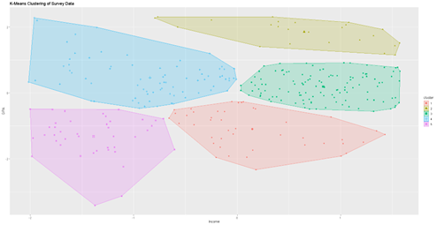As evidence for all these analyses, when we looked at the Clustering graph, we grouped the students according to their income levels and GPA. As a result of the clustering, the relationship between income and GPA was indeed seen.

In addition, PCA analysis (see appendix) showed that there is a strong relationship between Income, GPA and future concerns. According to these findings, urgent solutions to these problems should be proposed.

**Conclusion**

This research was conducted to shed light on the stress created by the economic conditions in Turkey on students; its effect on academic success and the inequality in education. According to the findings, we see that as the income level increases, the academic success of the students increases, and the anxiety about the future created by the irregular economy harms academic performance.

Moreover, the economy has also negatively affected the students' views on their future. Even a successful student in academic terms believes that he/she will not be able to earn a good income in the future. The best evidence for this data is that the question "If I experience a brain drain in the future, the main reason for this is the economy" is answered with a high rate of yes, it is because of the economy.

When we look at the inequality in education, which is the main reason for these two items, it has been seen that students who went to fee schools before university are more successful, which clearly reveals the inequality. In addition, the belief that students who receive financial support are more successful and that children of families with higher income levels will have better academic success is also common among students.

Generally speaking, economic conditions have the power to affect the future of students in Turkey and their academic careers. However, the findings show that instead of providing an equal education system for everyone, there is inequality in education. This problem should be taken seriously and long-term social injustice should be prevented.

**References**

Kemal, S. (2014,January). *SOSYOEKONOMİK AÇIDAN EĞİTİMDE FIRSAT EŞİTLİĞİ: GİRESUN ÖRNEĞİ MUSTAFA MALKOÇ YAŞAR Giresun Üniversitesi Lisansüstü Eğitim -Öğretim ve Sınav Yönetmeliğine Göre Sosyal Bilimler Enstitüsü İktisat Anabilim Dalı İçin Hazırlanan YÜKSEK LİSANS TEZİ (Giresun, Ocak 2014)*. Retrieved January 15, 2025, from https://acikbilim.yok.gov.tr/bitstream/handle/20.500.12812/87811/yokAcikBilim_10024136.pdf?sequence=-1

García, E., & Weiss, E. (2017, September 27). *Education inequalities at the school starting gate: Gaps, trends, and strategies to address them*. Economic Policy Institute. <https://www.epi.org/publication/education-inequalities-at-the-school-starting-gate/>

AKYILDIZ, İ. E. (2023). SOCIO-ECONOMIC DETERMINANTS OF BRAIN DRAIN FROM TURKEY TO THE UNITED STATES: THE CASE OF H-1B VISA. *Yönetim ve Ekonomi Araştırmaları Dergisi*, *21*(2), 22–38. https://doi.org/10.11611/yead.1217194

**Appendix**

**Table 1**

RESEARCH QUESTIONS AND SUBQUESTIONS

**Q1 Does the Turkish economy affect student success?**

1. Is it possible that students concentrate better in class and their grade point averages increase due to anxiety about the future?
2. Is it true that students' monthly income has a positive effect on their GPA?
3. What is the relationship between GPA, monthly income, and class level? Does the increase in GPA as class level increases depend on monthly income?

**Q2 How much does the Turkish economy affect students' thoughts about the future?**

1. Are students with lower monthly incomes more concerned about their future income?
2. How is the relationship between students' GPA and their concerns about future economic stability
3. How confident are students with low monthly income about their future?

**Q3 Does the economy play a role in the inequality between students in Turkey?**

1. Is there a difference in GPA between students who have attended private schools before and those who have not?
2. How important is monthly income to access academic resources? Are academic resources expensive?
3. Does financial power from the family affect educational performance?

**Survey questions**

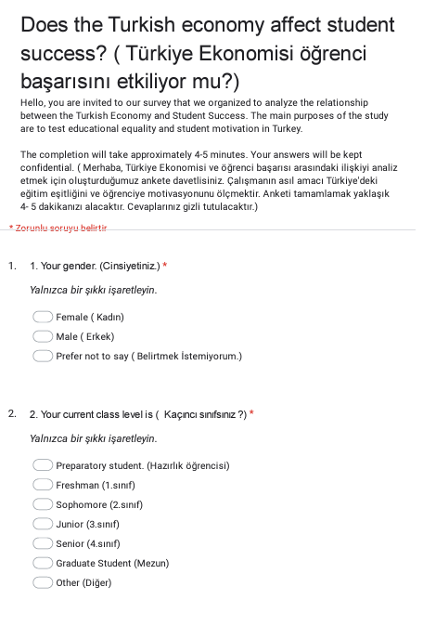

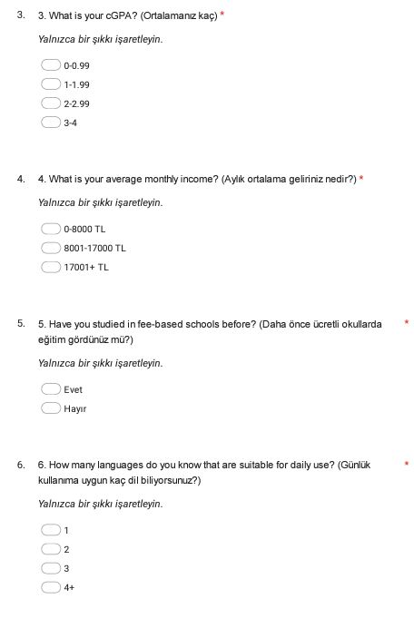

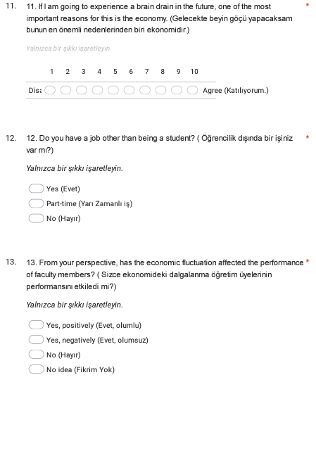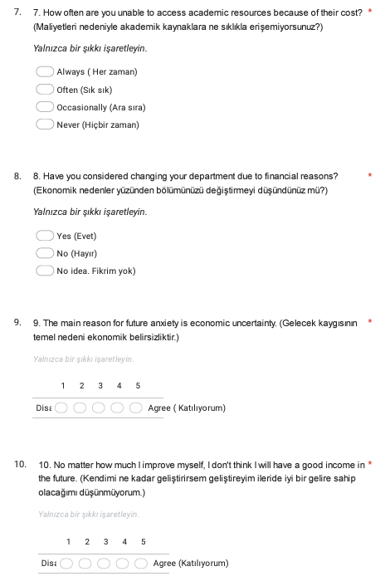

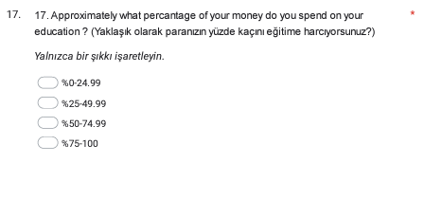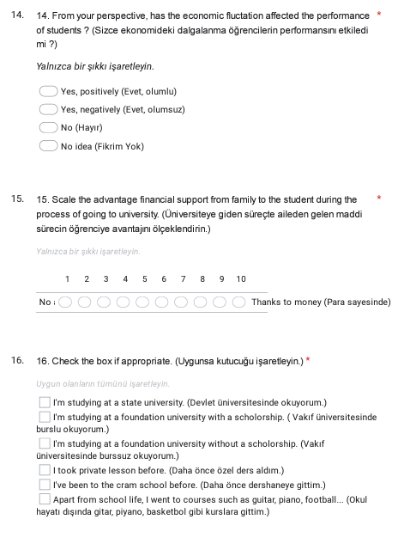

**Figure 1**

**Figure 2**

**Figure 3**

**Figure 4**

**Figure 5**

**Figure 6**

**Figure 7**

**Figure 8**

**Figure 9**

**Figure 10**

**Figure 11**

**Figure 12**

**Figure 13**

**Figure 14**

